Final Project Plan A - Calories App

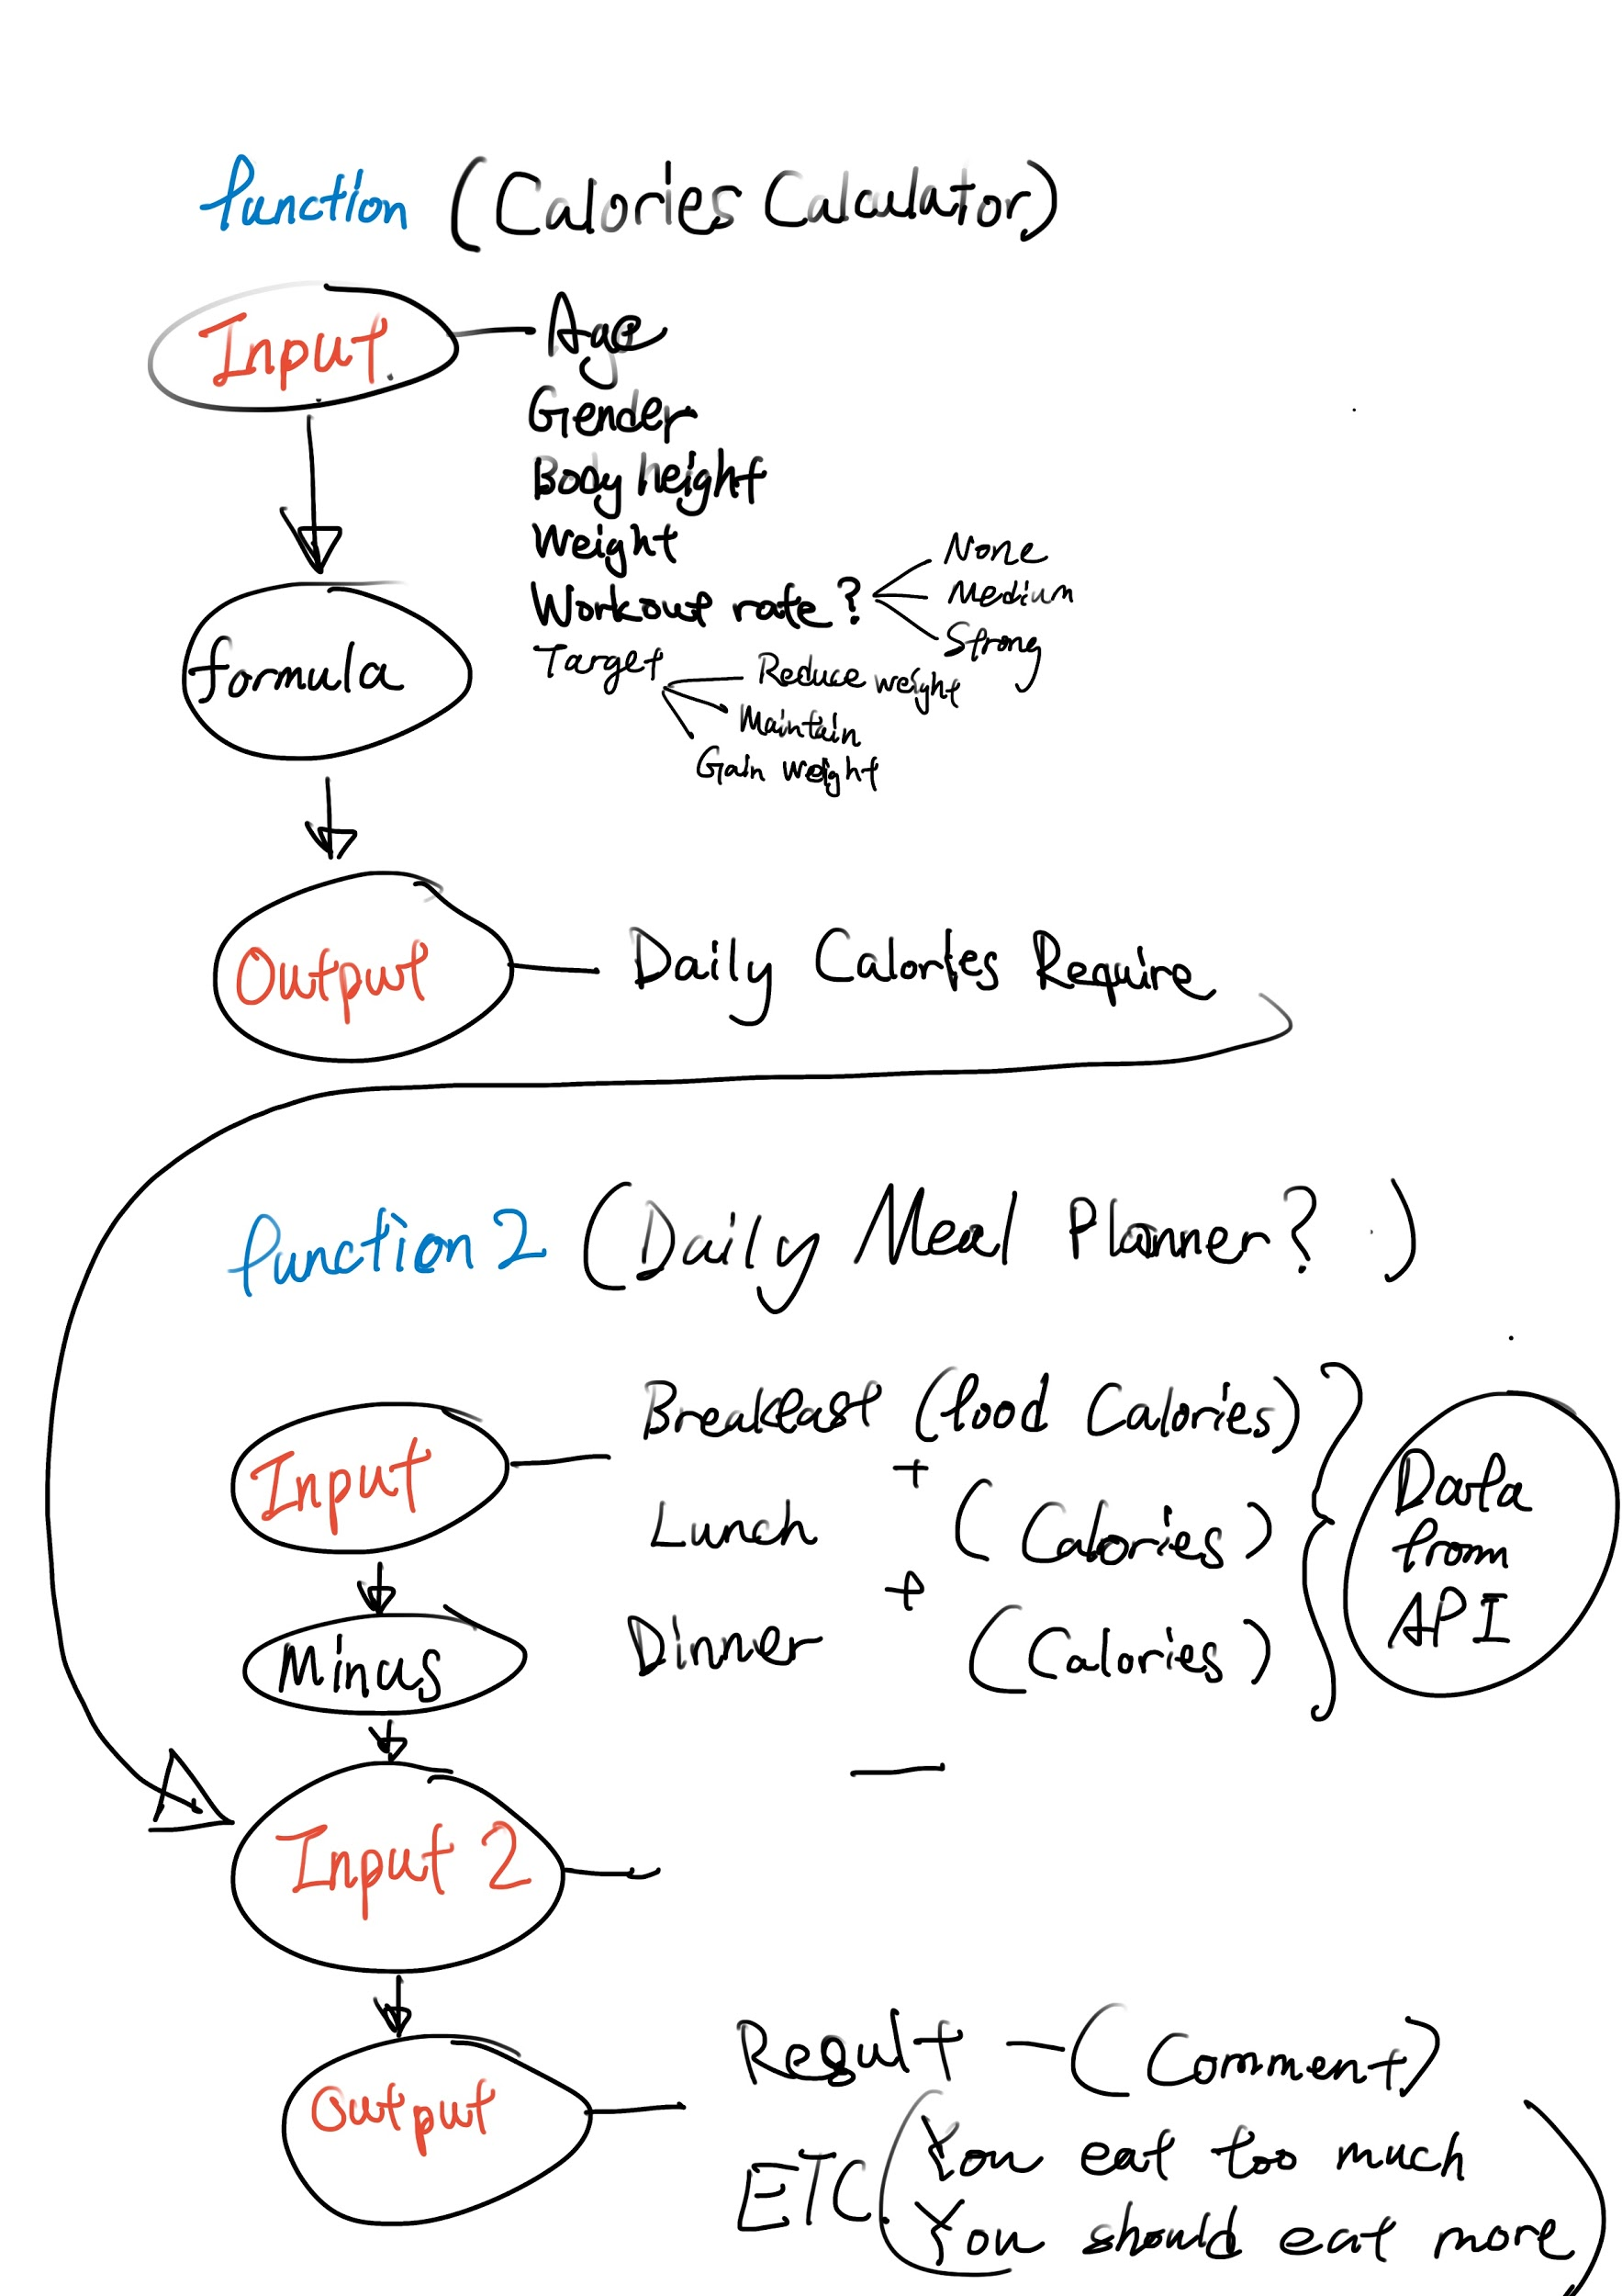

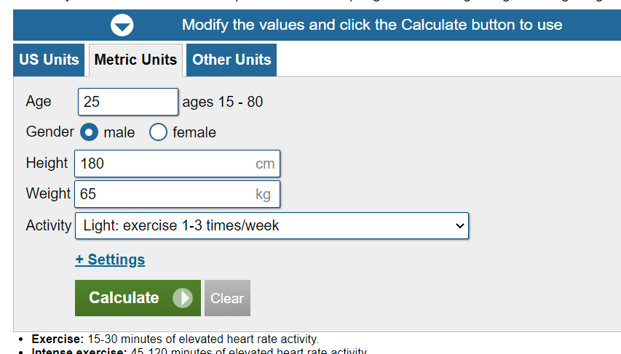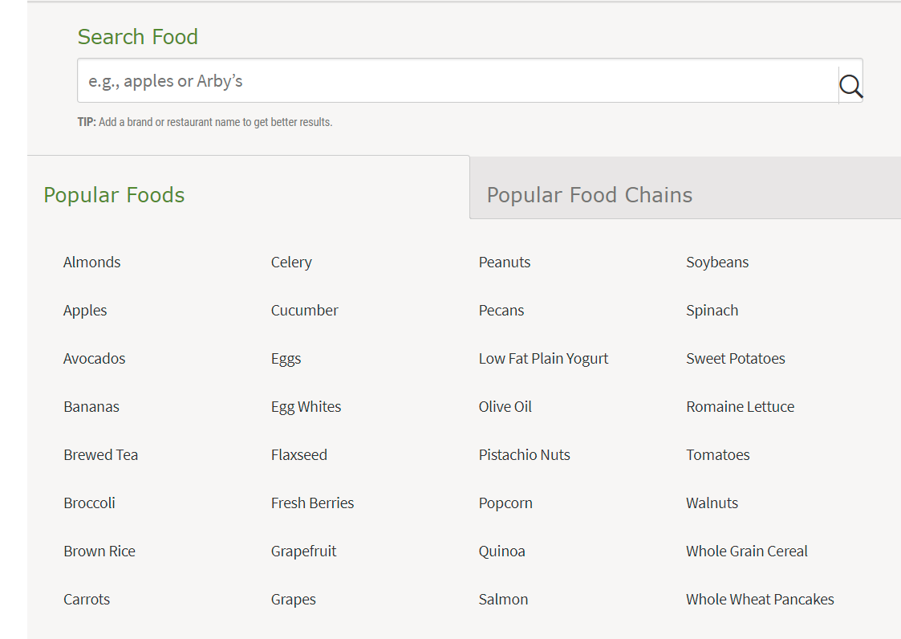

Food data base api

<https://rapidapi.com/edamam/api/edamam-food-and-grocery-database>

<https://spoonacular.com/food-api>

Calorie calculator reference

<https://www.calculator.net/calorie-calculator.html>